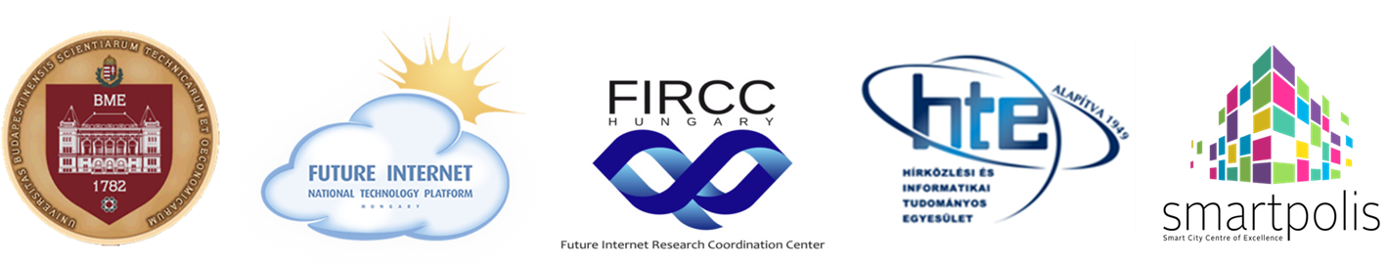

5th Hungarian Future Internet Conference
(5. Magyar Jövő Internet Konferencia – MJIK 2018)
» Focusing on Smart Cities «
Budapest University of Technology and Economics (BME), Central Building
November 28. 2018, in the frame of Month of Sciences

Main patron: Prof. Dr. János Józsa rector, BME

Preliminary Programme

8.30 - 9.30 Registration

9.30 – 12.00
Session 1: Smart City Trends, Plans and Results
Chairman: László Jakab, dean, BME VIK
János Józsa, rector, BME: Opening
- Fernando Lyardet (Urban Institute, Germany): Making Cities Smarter
- Martin Pečar (OmniOpti, Slovenia): Smart Towns in Slovenia
- David Barta (CityOne, Czech Rep.): Smart Services Framework in the Czech Republic
- Dejan Drajić (Dunavnet, Serbia): Novi Sad Evolution towards Smart City
- Gyula Sallai (BME TMIT): Next Generation Internet Perspectives
- László Mérő (ELTE): Who Is Afraid of Artificial Intelligence?
12.00– 13.30 Lunch break

13.30 – 15.00
Session 2: Future Internet Trends: the Next Generation Internet
(Jövő internet trendek: az internet következő generációja)
Chairman: Tamás Mihálydeák, FIRCC director, dean of DE IK
- Gábor Szűcs (BME TMIT): Deploying Driving Force: Artificial Intelligence
- Csaba Simon (BME TMIT): 5G and Network Softwarization
- Péter Baranyi (Széchenyi University, Győr): On the Efficiency of 3D Virtual Spaces
- Csaba Krasznay (Nat. Uni. of Public Service): Information Security vs. Cyber Security
- Imre Kocsis (BME MIT): Blockchain Technology in NGI

15.00 – 15.30 Coffee break

15.30 – 17.00
Session 3: Future Internet Based Solutions, Smart City Applications
(Jövő internet alapú megoldások, okos város alkalmazások)
Chairman: Péter Bakonyi, President of FI NTP, BME EIT
- Péter Bakonyi (BME EIT): V4 Smart Cities – assessing progress and priorities
- Márton Ispány (University of Debrecen): Smart City Living Lab and traffic analytics
- Sándor Nagy (Szeged): Smart City App’s in Szeged
- László Mátyus (EDC Debrecen): Smart City Projects in Debrecen
- Ákos Orbók (Nat. Uni. of Public Service): Cyber Security in Smart Cities
- Benedek Kovács (Ericsson Hungary): Smart Campus at the BME
Kálmán Kovács (Smartplis, BME EIT): Conference Closing

Dr. Peter Bakonyi  President, FI NTP | Prof. Dr. Gyula Sallai  Scientific Director, FIRCC

Prof. Dr. László Jakab
Dean, BME VIK

